# English 250, Course policies and tips

# Sections VH, TK. Spring 2018

# 

**Instructor:** Catherine (“Cath”) Engstrom **Email:** [catheng@iastate.edu](mailto:catheng@iastate.edu)

**Office:** 419 Ross Hall **Office Hours:** MWF 1-3 pm and by appt.

***Important: Course eligibility requirements***

You can’t get credit for English 250 unless you meet all of the following criteria: 1) successfully *completed* English 150 or earned exemption from your ACT-E/SAT-V or writing sample results, 2) completed or currently registered for Library 160, and 3) earned suitable score on EPT test (non-native speakers only). Drop now if you don’t qualify!

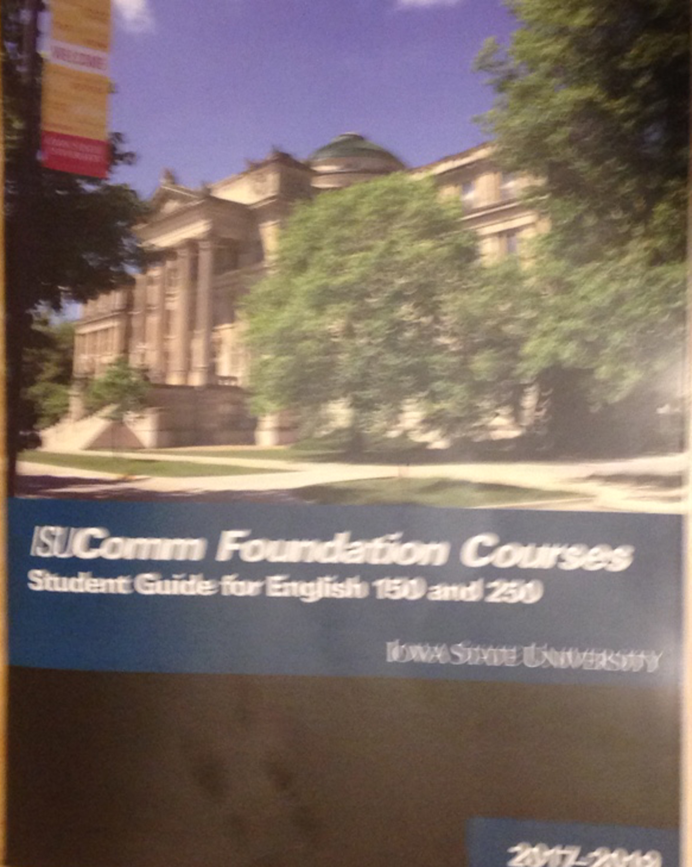**Textbooks and materials**

* *Sustainability: A Reader for Writers*. By Herndl, 2014.
* *Everything’s an Argument*, 7th ed. By Lunsford & Ruszkiewicz, w/2016 MLA updates
* *A Pocket Style Manual*, 8th ed. By Hacker and Sommers, 2017.
* *ISUComm Foundation Courses: Student Guide for English 150 and 250 (2017-2019),* published by ISU English Department.
* NOTE: Additional materials will be posted on Moodle. At times, you’ll be required to print them.
* 1 folder with pocket(s) to save all graded papers, feedback, etc., for your final e-portfolio
* Microsoft Word and PowerPoint on your computer for use in storing/uploading all course documents and giving presentations. (You can get the Microsoft Office Suite at a huge student discount from the ISU bookstore; it includes both programs.)

***Major assignments & approximate grade distribution***

Participation & short writing assignments: 10%

Class participation and discussion, peer reviews

Short papers (intro quiz, prewriting, reflections, etc.)

Major projects (papers & presentations) 90%

Paper 1: Reflecting on self as a communicator 10 pts (automatic if on time)

Paper 2: Summarizing sources 40 points

Graded Discussion 50 points

Paper 3: Rhetorical analysis of Writing (2 versions) 15 + 150 points (165)

Paper 4: Rhetorical analysis of Visuals (2 versions) 15 + 150 points (165)

Oral presentation on Paper 3, using ad 60 points

Paper 5: Research paper (2 versions) 20 + 200 points (220)

Oral presentation on Paper 5, using PowerPoint 150 points

Paper 6, part 1 (Course Portfolio/reflection) 100 points

Paper 6, part 2 (Final exam) 40 points

TOTAL major points 1,000 points

***\*See Attendance policy (page 3) to learn potential impact of class absences on your final grade.*Course objectives & theme**

English 250 is designed to help you develop skills in **written, oral, visual, and electronic (WOVE) communication** along with the underlying skills of critical reading and thinking. As a result, you will become not only a more perceptive *consumer* of communications but also a more accomplished *creator* of communications – whether in future college classes, workplace or personal life. You’ll learn to summarize, analyze, and evaluate various types of communication and then use those skills in your writing assignments. For a more detailed breakdown of WOVE elements and objectives, see your Student Guide, pages 2 & 6.

Our semester’s theme is Sustainability. We’ll interpret this theme in the broadest light possible so that each student can relate it to his/her interests and major. By the end of the course, you should have a much broader and richer view on these topics, including their relationship to your life and work.

**Grading and Evaluation**

In English 250, as in other university courses, the work required of you at the university will often be different in type and level of difficulty from what you did in high school. Expectations are also naturally higher since your work is now in a pool with that of others who are also pursuing a degree at this large university. It is assumed that students admitted to the university can perform satisfactorily most of the time; however, earning As and Bs at the university level requires strong, consistent effort. Your assignment sheets in English 250 include evaluation criteria and your instructor will provide feedback on your work. Be realistic in your expectations about grades; start assignments early and work steadily to avoid last-minute rushing.

A The qualities of a B assignment, plus imagination, originality, and engaging expression.

B Thorough analysis of the communication problem; a satisfactory solution to the problem, judgment and tact in the presentation of this solution; good organization and solid expression.

C **Satisfactory analysis of the problem, clear organization, and competent style; nothing remarkably good or bad. A C means your work met the demands of the assignment in a minimally acceptable way.**

D Presence of a significant defect in context, substance, organization, style, or delivery in a lackluster paper; inadequate treatment of the assignment.

F Inadequate coverage of essential points, uncertain or misguided purpose, poor organization; ineffective and inconsistent expression; significant defects in standard usage.

***Engstrom’s grading scale (by percent)***

A = 95-100%, A- = 90-94

B+ = 87-89, B = 83-86, B- = 80-82

C+ = 77-79, C = 73-76, C- = 70-72

D+ = 67-69, D = 63-66, D- = 60-62

F = below 60% (Note that more points separate a 0 and a high F than separate an F and an A. In other words, it’s possible to pass the course even if you earn an F on one major assignment, but it’s almost impossible to recover from a 0.

***Late work penalties:***  Major assignments will be penalized one letter grade (e.g., from B to C) for each day (including non-class days) that they are late. Shorter assignments, which often include time-sensitive planning steps for larger assignments, will lose substantial (or all) points if late. If you’re missing a deadline due to unusual circumstances, talk to instructor about POSSIBLE exceptions before the due date.

**Class Attendance and Participation**

* This class uses a discussion/workshop format and depends on your active learning. Therefore, regular attendance and productive, courteous participation with classmates and instructor are important. Much of what we do in English 250 cannot be rescheduled for you individually, made up, or accepted late, regardless of your reason for missing class. Absences damage your grade in the class and create the probability that you need to drop the course. That costs you money while wasting a class space another student could have used.
* **How class absences affect your grade.** To ensure that you stay on track, the following policies were developed by the Director of ISUComm Foundation Courses and are enforced in this section (and all sections) of English 250:
  + 5 - 8 absences: Your final grade is reduced two increments (a B+ becomes a B-; a C becomes a D+). This happens for the *range* of 5-8 absences, not for each individual absence within the range. Even so, the impact on your grade is severe once you go over four absences.
  + **9+ absences: You must drop the course or you’ll receive an F.** (See next page.)
* **Excessive absences (9+).** Even with *valid* reasons for missing classes, excessive absences result in your work and classroom experience becoming too compromised for you to remain in the class. The Director of ISUComm Foundation Courses and your instructor will advise you and your advisor if your absences—regardless of their reason—are too numerous for you to remain in English 250H. In this case, you need to drop the class and take it in a semester when your schedule permits regular attendance.
  + Please do not assume that exceptions will be made for you. If you are concerned about the number of times you anticipate missing, speak to your instructor or the Director of ISUComm Foundation Courses ([blakely@iastate.edu](mailto:blakely@iastate.edu)) immediately. If there is a medical condition, speak to the Student Disability Resources Office at the beginning of the semester. If the class’s meeting time is inconvenient for you, talk to your advisor now.
* If you arrive more than 15 minutes late to class, you will be counted absent.
* **Absences during group work or on the day of your oral presentation means taking an F for that activity**, as it cannot be made up individually.
* When individual conferences replace 2-3 class periods, missing your scheduled conference counts as TWO absences.
* Your advisor will also be notified of attendance issues that threaten your ability to pass the class and you may receive a midterm low-grade report because of your attendance.
* **Don’t schedule travel that requires you to leave campus early for Fall Break or finals week**, as this could conflict with your class and/or your final exam. Your instructor cannot make individual arrangements for you.

**Getting the most from Moodle**

This course is managed through Moodle, and you can get all relevant information there. Get in the habit of checking the Moodle several times weekly. Here are ways you can/should use the site:

* Check site a day or two before EACH class period **to prepare for class** (to find/do homework, read guidelines and other online resources, get special instructions, etc.).
* Use site **when uploading assignments** (also to double-check assignment requirements, due dates, etc.)
* Use site to **access graded papers & instructor comments**. Generally you’ll get an email when the instructor has uploaded a graded paper. Go to the site to look for the FEEDBACK file sent by instructor and download that to your own computer. Open that file in Word and check the REVIEW tab to make sure you’re seeing all the comments. Under that tab, click “All Markup” and then check the first four items under “Show Markup.”
* Check site regularly to **view your grades on individual assignments and/or the course as a whole.**
* Check site for **announcements/updates** like last-minute changes to deadlines, classrooms, or the like.
* NOTE: If you have questions about the course/assignment info on Moodle, contact the instructor. If you’re having technical difficulties with Moodle, send an email to [moodle@iastate.edu](mailto:moodle@iastate.edu) that describes your problem. Include your course and section #.

**Formatting/submission guidelines for all papers**

* **Program:** Submit all papers as Word documents, which usually have an extension of *docx*.Because the instructor will be using the tracking and revision features of Word, it’s hard to submit papers in other programs. If you aren’t already using this program, you can get the entire Office suite (including Word) for $10 through the ISU Bookstore. It’s a standard set of programs used by most businesses and is worth learning anyway.*If getting/using Word is a problem for you, talk to the instructor asap.*
* **MLA format:** Whether submitting your papers in print or electronically, follow the MLA manuscript format guidelines. See PSM pages 167-171 for details. These guidelines cover margins (1”), line-spacing (double-spaced), fonts, page numbers (running head), visuals, Works Cited list, etc.
* **Exception to MLA format.** PSM 167 shows the standard identification block that appears on the FIRST page of your papers (top left-hand corner). Follow those guidelines EXCEPT for revising that block as shown below:

Your name

English 250H, section XX

Paper #_, version #_

Date

Target audience: xxxx

**NOTE:** This ID block is normally double-spaced, but you MAY single-space it to save paper. Once you get past this ID heading, the rest of the paper MUST be double spaced. Each new paragraph should be indented ½” with no extra lines between paragraphs.

**ADDITIONAL GUIDELINES FOR MAJOR PAPERS:**

* **First versions:** For peer review, bring a printed copy to class with peer rubric stapled to back. When peer review is complete, make revisions, and upload your final version to Moodle (with grading rubric pasted in as last page).
* **Final versions:** All final versions should be uploaded to Moodle as a single document in the following order: Final version and grading rubric.
* Save all graded papers (1st & final versions) and all teacher/peer comments for your final portfolio project.

**SHORT ASSIGNMENTS:** In addition to these major assignments, you’ll complete several shorter, related assignments – such as pre-writing steps and post-assignment reflections. Your grades for these assignments, combined with your class participation, account for 10% of your total grade.

**NEED EXTRA HELP?** If you have questions about an assignment or need extra help, feel free to contact the instructor during office hours or send an e-mail. For extended help, make an appointment at the ***Writing & Media Help Center*** (208 Carver Hall, 294-5411; free!).

**Other important policies/info**

***Academic Honesty***

Plagiarism (using others’ words or ideas without proper documentation) is a serious legal and ethical breach, and it is treated as such by the university. To avoid inadvertent plagiarism, read the relevant sections in your *Student Guide: English 150–250.* When in doubt about correct documentation, see your instructor *before* you turn in an assignment. Instructors who detect plagiarism are *required* to notify the Director of Foundation Communication and consult her about consequences.

***Computer Ethics***

Please check the *Student Guide: English 150–250* for information on the university's computer ethics policy. You are expected to use the university computers responsibly and to communicate courteously with others in your class—including the instructor—electronically. You are also expected to follow your instructor’s instructions on class days in the lab, using the computers for class-related activity only.

***Diversity Affirmation***

Iowa State University does not discriminate on the basis of race, color, age, ethnicity, religion, national origin, pregnancy, sexual orientation, gender identity, genetic information, sex, marital status, disability, or status as a U.S. veteran. Effective learning environments value and support diversity. Respect the learning environment and learning needs of other students through appropriate behavior and civility.

***Civility***Always treat your classmates and instructor with dignity & respect. When opinions differ, keep it civil. Remember that *good people must sometimes agree to disagree*—and then move on, without attacking the other’s character.

***Disability Accommodation***

If you have a disability and require accommodations, you must contact your instructor early in the semester so that your learning needs may be appropriately met. You will need to provide documentation of your disability to the Disability Resources (DR) office, main floor of the Students Services Building, Room 1076, 515-294-7220.

***Writing and Media Center***

The Writing and Media Center (WMC) helps students become stronger, more confident communicators. The WMC is a welcoming and inclusive peer tutoring center where friendly Communication Consultants offer individualized assistance to undergraduate and graduate students working on any form of written, oral, visual, or electronic (WOVE) communication. The WMC also offers a variety of workshops each semester. All services are FREE! To learn more about the WMC, please visit www.wmc.dso.iastate.edu.

***And don’t forget….***

If you have a question about a specific assignment or other issue, feel free to ask your instructor – in class (or just before/after), by e-mail, or during my office hours or another pre-arranged time. It’s my job—but more importantly, I enjoy talking with students and like knowing that you care enough to ask questions.